**Student Name: Sofia Young**

**Access Code (located on the underside of the lid of your lab kit):** Click here to enter text.

**Pre-Lab Questions”**

1. Use Figure 3 to measure the diameter of the quarter.

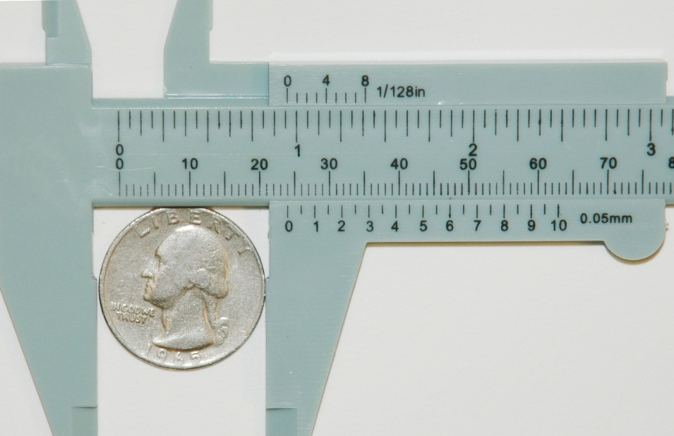

**20 mm**

***Figure 3: A quarter being measured by a caliper.***

1. Why is uncertainty important to consider when reporting data?  
   **Uncertainty is important to consider when reporting data because it reflects the degree of confidence or reliability in the measurements or observations made.**

**EXPERIMENT 1: RULERS VS. CALIPERS**

Data Table

Table 1. Ruler and Caliper Measurements

|  |  |  |  |  |
| --- | --- | --- | --- | --- |
| **Object** | **Ruler** | | **Caliper** | |
| **Measurement (cm)** | **Uncertainty (cm)** | **Measurement (cm)** | **Uncertainty (cm)** |
| **Marble Diameter** | **1.5cm** | **0.05cm** | **1.5cm** | **0.05cm** |
| **Washer (Outer Diameter)** | **2.5cm** | **0.05cm** | **2.5cm** | **0.05cm** |
| **Washer (Inner Diameter)** | **2 cm** | **0.024cm** | **2 cm** | **0.024 cm** |
| **Washer Thickness** | **0.32 cm** | **0.022 cm** | **0.32 cm** | **0.022 cm** |
| **String Length** | **16.24 cm** | **0.022 cm** | **16 cm** | **0.022 cm** |
| **Styrofoam® Cup Height** | **8.25 cm** | **0.02 cm** | **8 cm** | **0.02** |

## Post-Lab Questions

1. Compare the measurements for objects using the ruler and caliper and write a general statement on when it is more beneficial to use a ruler rather than a caliper.

**It is more beneficial to measure objects using a ruler when measuring large objects. In contrast, when measuring small objects with higher precision, a caliper is more beneficial. The choice between using a ruler or a caliper depends on the precision and accuracy needed, as well as the size of the object.**

1. Comment on accuracy vs. precision for rulers and calipers.  
   **Rulers are generally less precise than calipers, but they can be very accurate for measuring larger distances. Calipers are designed to measure smaller dimensions and are more precise than rulers.**
2. What are the sources of uncertainty when using a ruler and caliper?

**Sources of uncertainty when using a ruler and caliper can be human error, instrumental errors, and reading errors.**

**EXPERIMENT 2: THE SPRING FORCE SCALE**

Data Table

Table 2. Spring Scale Measurements

|  |  |  |  |  |
| --- | --- | --- | --- | --- |
| **Object** | **5 N Spring Scale Weight (g)** | **Uncertainty (g)** | **10 N Spring Scale Weight (g)** | **Uncertainty (g)** |
| **5 gram mass set** | **5 g** | **0.5 g** | **5 g** | **1 g** |
| **Box of modeling clay** | **454 g** | **0.5 g** | **452 g** | **1 g** |
| **Roll of masking tape** | **145 g** | **0.5 g** | **144 g** | **1 g** |
| **Single hole punch** | **100 g** | **0.5 g** | **98 g** | **1 g** |

## Post-Lab Questions

1. What are the advantages and disadvantages of using a spring scale to measure weight?  
   **Some advantages of using a spring scale to measure weight are that they are simple to use and can be used to measure weight in a variety of settings. The disadvantages of using a spring scale to measure weight are that they can be less accurate than other types of scales and they may not be suitable for measuring very small or very large weights.**
2. What are sources of uncertainty when using a spring scale?   
   **Some sources of uncertainty when using a spring scale are calibration errors, friction causing inaccurate readings, and user errors.**

**EXPERIMENT 3: THE STOPWATCH**

Data Table

Table 3. Time Data for Dropped Marble

|  |  |
| --- | --- |
| **Drop (Trial)** | **Time (s)** |
| **1** | **0.43** |
| **2** | **0.41** |
| **3** | **0.39** |
| **4** | **0.46** |
| **5** | **0.4** |

## Post-Lab Questions

1. What are the advantages and disadvantages of using a stopwatch to measure time?  
   **Some advantages of using a stopwatch to measure time are the accuracy and simplicity of it. Some disadvantages of using a stopwatch to measure time include human error and limited functionality.**
2. What are sources of uncertainty when using a stopwatch?  
   **Sources of uncertainty when using a stopwatch include stopwatch inaccuracy, human reaction time uncertainty, human errors, and systematic errors.**

**EXPERIMENT 4: DESTINY OF THE MASS SET**

Data Tables

Table 4. Mass Set Density Data

|  |  |  |
| --- | --- | --- |
| **Quantity** | **Measurement** | **Uncertainty** |
| **Height (cm)** | **2.5 cm** | **0.1 cm** |
| **Radius (Diameter/2), r (cm)**  **Or**  **Base Edge Length, b (cm)** | **1.25 cm** | **0.1 cm** |
| **Volume, V (cm3)** | **12.27** | **N/A** |
| **Mass (g)** | **100 g** | **1 g** |
| **Density (g/c3)** | **8.14** | **N/A** |

Table 5: Known Densities of Various Materials

|  |  |
| --- | --- |
| **Material** | **Density at 20ºC** |
| Aluminum | **2.70 g/cm3** |
| Copper | **8.92 g/cm3** |
| Lead | **11.34 g/cm3** |
| Nickel | **8.90 g/cm3** |
| Silver | **10.50 g/cm3** |
| Steel | **7.80 g/cm3** |
| Zinc | **7.14 g/cm3** |

## Post-Lab Questions

1. Use Table 5 to determine what material the mass set is made of. Be sure to take your uncertainty into consideration.   
   **Taking my uncertainty into consideration, I think that the mass set is made of steel.**

**Take a photo of your Vernier caliper measuring your Mass Set. Be sure to have your name handwritten in the background of the photo.**   
